GUT CACAO: Premium 100% Pure Cacao Paste
B2B Sales Pitch – English Version
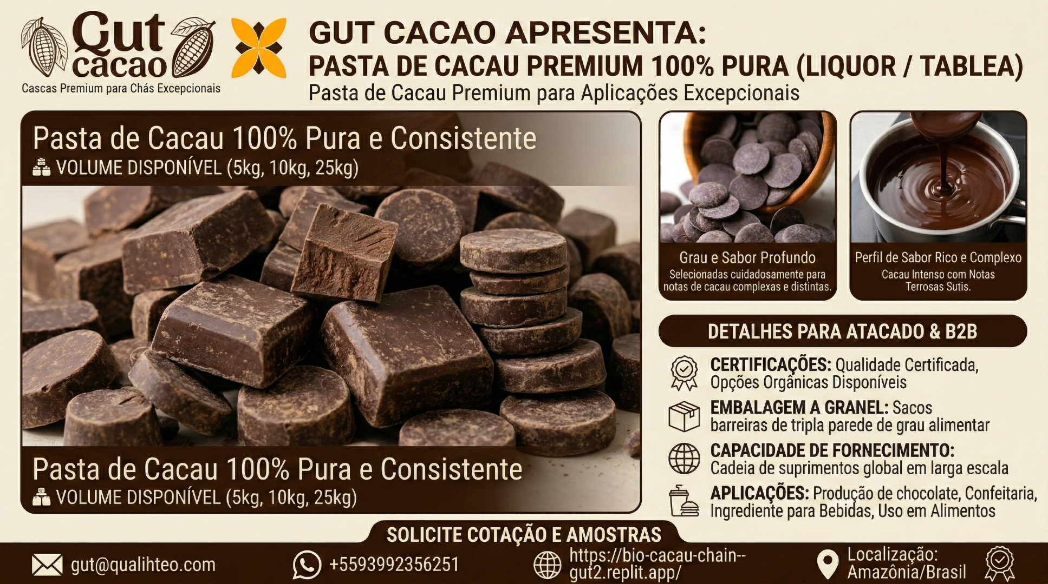

Elevate Your Chocolate with Amazonian Excellence
GUT CACAO presents Premium 100% Pure Cacao Paste (Liquor/Tablea) – the foundation of exceptional chocolate, sourced directly from the Amazon rainforest and crafted with precision for industrial and artisan applications.

Why Choose GUT CACAO Premium Cacao Paste?
Uncompromising Quality from Source to Block
Our cacao paste delivers the consistency, traceability, and flavor complexity that premium chocolate manufacturers demand. Every block represents the culmination of advanced post-harvest infrastructure, digital fermentation monitoring, and solar-hybrid drying technology – all located in the heart of the Amazon[1].
Deep Grade Flavor Profile
Carefully selected beans yield complex and distinct cacao notes with layers of earthy, fruity, and nutty undertones. Our rigorous fermentation protocols (pH, Brix, temperature monitoring with hydraulic turning) ensure repeatable sensory profiles batch after batch[1].
Rich and Intense Cacao Experience
The silky smooth texture at 18–22 microns particle size delivers an intense cacao base with subtle earthy notes – perfect for premium couverture, bean-to-bar chocolate, confectionery, and specialty beverage applications[1][2].

Wholesale & B2B Details
Certifications: Certified quality with organic options available. Cocoa of Excellence Award Winner recognition[1].
Bulk Packaging: Available in 5 kg, 10 kg, and 25 kg blocks. Triple-walled, food-grade barrier bags for optimal freshness and logistics efficiency[1].
Supply Capacity: Large-scale global supply chain with direct Amazon origin. Container and pallet shipments available with full traceability via QR code per batch[1].
Applications: Chocolate production, confectionery, beverage ingredient, food manufacturing, and specialty culinary uses.

The GUT CACAO Advantage: From Clone to Container
- Traceable Origin: Every batch tracked from agroforestry systems in Pará, Brazil, with digital biometric reception and lot segregation[1].
- Advanced Fermentation: Wooden fermentation boxes with real-time monitoring and internal cut tests ensure optimal flavor development[1].
- Hybrid Precision Drying: Slow solar greenhouse drying (4–6 days) combined with smoke-free wood drying to 7% moisture for food safety and shelf stability[1].
- Industrial Processing Line: Controlled roasting, fine grinding to 18–22 microns, and scalable production for global contracts[1][2].
- Bioeconomic Impact: Supporting rainforest preservation while increasing farmer income by up to 300% through fair partnerships and technical assistance[1].

Technical Specifications
Product | 100% Pure Cacao Paste (Cocoa Liquor)
Particle Size | 18–22 microns (fine grinding)
Moisture Content | 7% (controlled drying)
Packaging Options | 5 kg, 10 kg, 25 kg blocks
Origin | Amazon rainforest, Pará, Brazil
Certifications | Quality certified, organic options
Fermentation | Type 1 fermented beans, monitored protocol
Traceability | QR code per batch, clone to container

Table 1: GUT CACAO Premium Paste Specifications

Your Competitive Edge
In a volatile cacao market, reliability and consistency are your greatest assets. GUT CACAO delivers:
Predictable flavor profiles for formula stability
Continuous supply without bottlenecks
Compelling sustainability story for brand differentiation
Direct origin relationship eliminating middleman costs

Request Quote & Samples
Connect your production to the Amazon origin with measurable quality, powerful sustainability narrative, and stable supply.
Contact: Helton Gutzeit, CEO & Founder
Email: gut@qualihteo.com
WhatsApp: +55 93 99235-6251
Website: https://bio-cacau-chain--gut2.replit.app/
Location: Amazonia, Brazil
Let's build a partnership that elevates your chocolate while protecting the rainforest.

References
[1] Qualitheo. (2026). Agroindústria Bioeconômica da Amazônia – Bio Cacao Chain. https://bio-cacau-chain--gut2.replit.app/
[2] RADAD International. (2026). Cocoa Mass (Cocoa Liquor): The Complete Guide to Understanding, Using, and Buying the Foundation of Chocolate. https://radadinternational.com/cocoa-mass-cocoa-liquor-the-complete-guide-to-understanding-using-and-buying-the-foundation-of-ch

